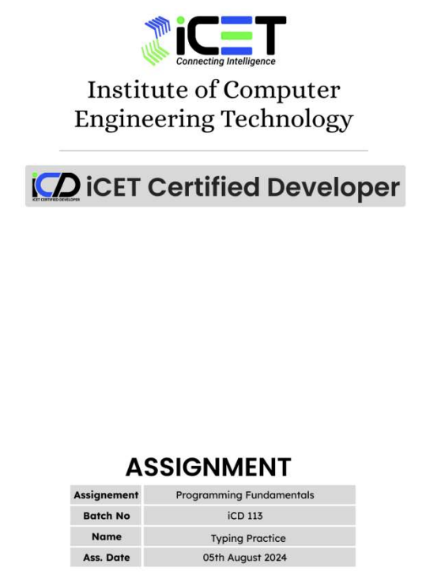

**PR2411302 Thisuli Lohansa**

**Q1.**

class Example {

public static void main(String args[]){

System.out.println("Institute of Computer Engineering Technology");

}

}

**//- Output**

E:\ICET\Assignment1>java Example

Institute of Computer Engineering Technology

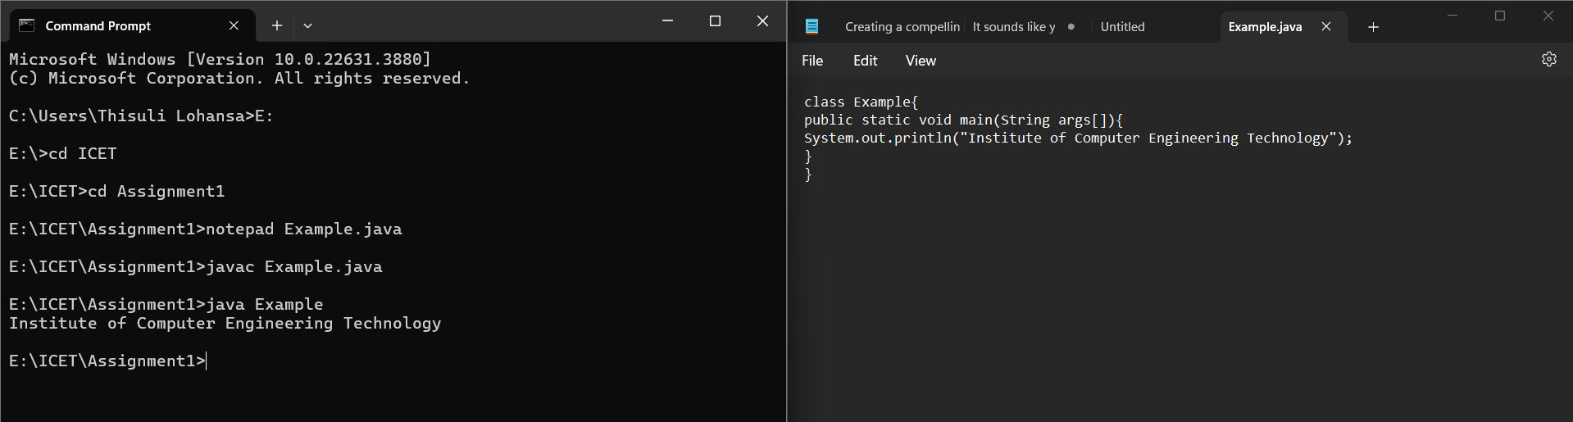

**Q2.**

class Example {

public static void main(String args[]){

System.out.println("Institute of Computer Engineering Technology");

System.out.println(“223 A,”);

System.out.println(“Galle Road,”);

System.out.println(“Panadura”);

}

}

**//- Output**

E:\ICET\Assignment1>java Example

Institute of Computer Engineering Technology

223 A,

Galle Road,

Panadura.

**Q3.**

class Example{

public static void main(String args[]){

System.out.print(“J”);

System.out.print(“A”);

System.out.print(“V”);

System.out.print(“A”) ;

}

}

**//- Output**

E:\ICET\Assignment1>java Example

JAVA

Q4.

class Example{

public static void main(String args[]){

System.out.println(“1”);

System.out.println(1000);

System.out.println(1.23);

}

}

//- Output

E:\ICET\Assignment1>java Example

1

1000

1.23

Q5.

class Example{

public static void main(String args[]){

System.out.println(“Hello”);

System.out.println(“A”);

System.out.println(1234);

System.out.println(-1234);

System.out.println(1.2334);

System.out.println(0.0032);

System.out.println(-1234);

System.out.prinln(‘A’);

System.out.prinln(‘6’);

System.out.prinln(True);

System.out.prinln(false);

}

}

//- Output

E:\ICET\Assignment1>java Example

Hello

A

1234

-1234

1.2334

0.0032

-0.0023

A

6

true

false

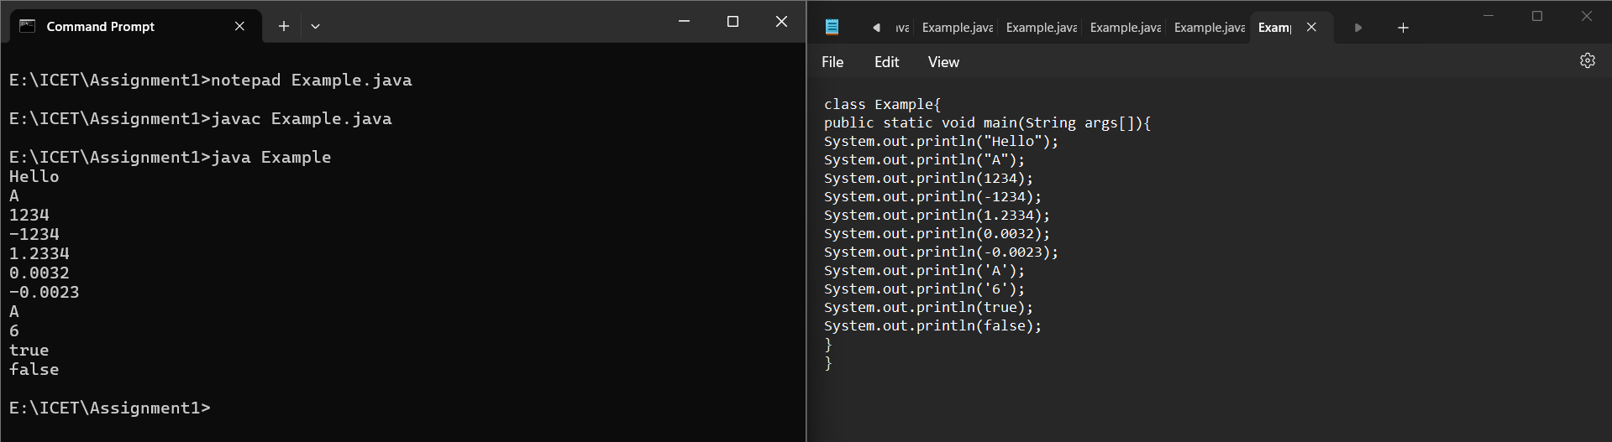

Q6.

class Example{

public static void main(String args[]){

System.out.print(“A”);

System.out.print(“B”);

System.out.print(“C”);

System.out.print(“D”);

}

}

//- Output

E:\ICET\Assignment1>java Example

ABCD

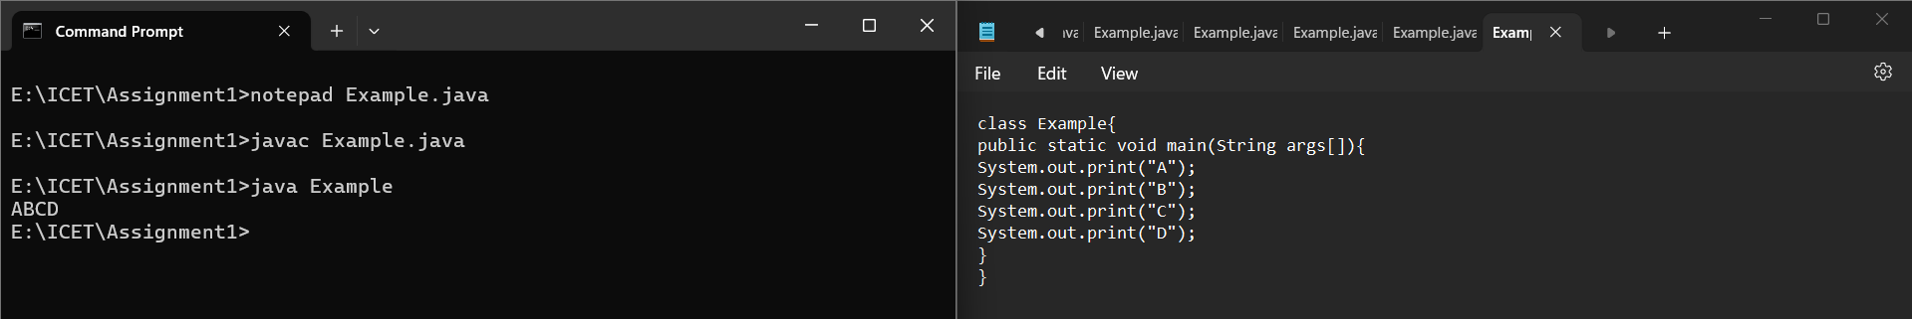

Q7.

class Example{

public static void main(String args[]){

System.out.println(“1”);

System.out.print“2”);

System.out.println(“3”);

System.out.print(“4”);

System.out.print(“5”);

System.out.println(“6”);

System.out.print(“7”);

System.out.print(“8”);

System.out.print(“9”);

System.out.println(“10”);

}

}

//- Output

E:\ICET\Assignment1>java Example

1

23

456

78910

Q8.

class Example{  
 public static void main(String args[]){

System.out.print(“1”);

System.out.println();

System.out.print(“2”);

System.out.print(“3”);

System.out.println();

System.out.print(“4”);

System.out.print(“5”);

System.out.print(“6”);

System.out.println();

System.out.print(“7”);

System.out.print(“8”);

System.out.print(“9”);

System.out.print(“10”);

}

}

//- Output

E:\ICET\Assignment1>java Example

1

23

456

78910

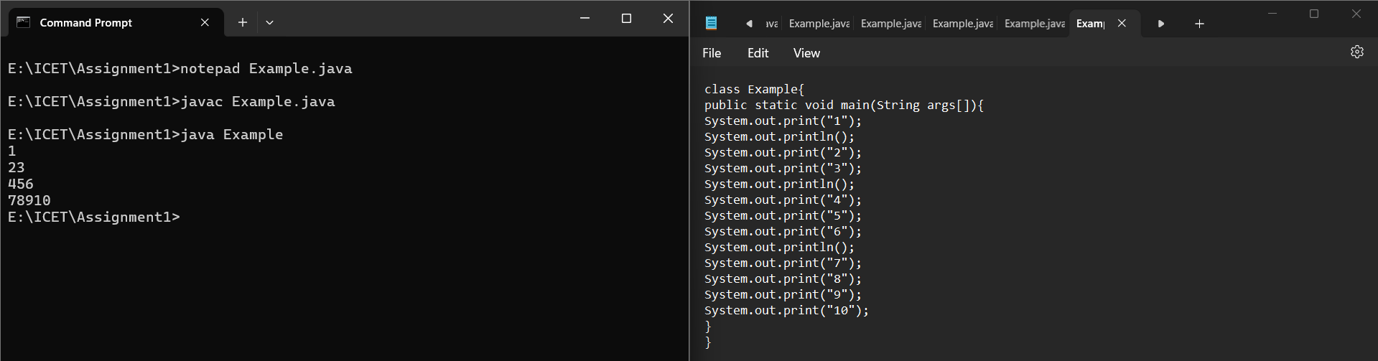

Q9.

class Example{

public static void main(String args[]){

System.out.println(“A”);

System.out.println(“B”);

System.out.println();

System.out.println(“C”);

System.out.println(“D”);

System.out.print(“”);

}

}

//- Output

E:\ICET\Assignment1>java Example

A

B

C

D

Q10.

class Example{

public static void main(String args[]){

System.out.println(“A”);

System.out.println(“B”);

System.out.println();

System.out.println(“C”);

System.out.println(“D”);

}

}

//- Output

E:\ICET\Assignment1>java Example

A

B

C

D

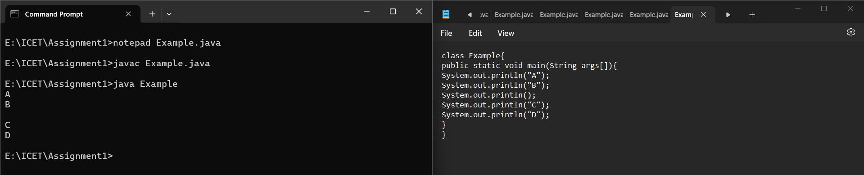

Q11.

class Example{

public static void main(String args[]){

Int a;

A = 100;

System.out.println(“a”);

System.out.println(a);

}

}

//- Output

E:\ICET\Assignment1>java Example

a

100

Q12.

class Example{

public static void main(String args[]){

int a;

System.out.println(“a”);

System.out.println(a);

}

}

**//- Output**

E:\ICET\Assignment1>javac Example.java

Example.java:5: error: variable a might not have been initialized

System.out.println(a);

^

1 error

Q13.

class Example{

public static void main(String args[]){

int a=100;

System.out.println(a);

}

}

//-Output

E:\ICET\Assignment1>java Example

100

Q14.

class Example{

public static void main{String args[]){

int a;

System.out.println(a);

a =100;

}  
}

//- Output

E:\ICET\Assignment1>javac Example.java

Example.java:4: error: variable a might not have been initialized

System.out.println(a);

^

1 error

Q15.

class Example{

public static void main(String args[]){

int x;

x =100;

x=200;

System.out.println(x);

}

}

//- Output

E:\ICET\Assignment1>java Example

200

Q16.

class Example{

public static void main(String args[]){

int x;

X =100;

System.out.println(x);

X =200;

System.out.println(x);

}

}

//- Output

E:\ICET\Assignment1>java Example

100

200

Q17.

class Example {

public static void main(String args[]){

int x=100;

int y=200;

System.out.println(x);

System.out.println(y);

}

}

//- Output

E:\ICET\Assignment1>java Example

100

200

Q18.

class Example {

public static void main(String args[]){

int x;

x=1000;

System.out.println(x);

var y=2000;

System.out.println(y);

}

}

//- Output

E:\ICET\Assignment1>java Example

1000

2000

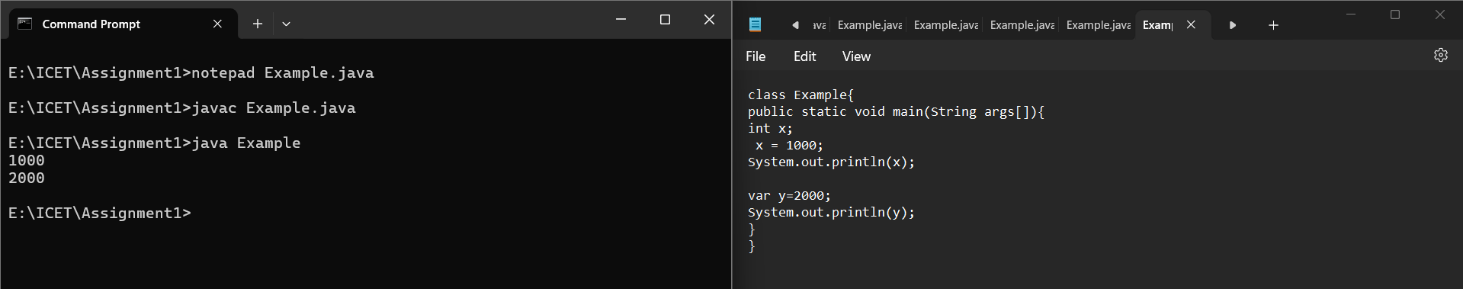

Q19.

class Example {

public static void main(String args[]){

int x=100;

int y=200;

int z;

System.out.println(x);

System.out.println(y);

System.out.println(z);

}

}

//- Output

E:\ICET\Assignment1>javac Example.java

Example.java:8: error: variable z might not have been initialized

System.out.println(z);

^

1 error

Q20.

class Example {

public static void main(String args[]){

int x=100,y,z=200;

System.out.println(x);

y="java";

System.out.println(y);

System.out.println(z);

}

}

//- Output

E:\ICET\Assignment1>javac Example.java

Example.java:5: error: incompatible types: String cannot be converted to int

y="java";

^

1 error

Q21.

class Example {

public static void main(String args[]){

System.out.println(“A”);

// System.out.println(“B”);

System.out.println(“C”);

// System.out.println(“D”);

System.out.println(“E”);

}

}

//- Output

E:\ICET>java Example

A

C

E

E:\ICET>

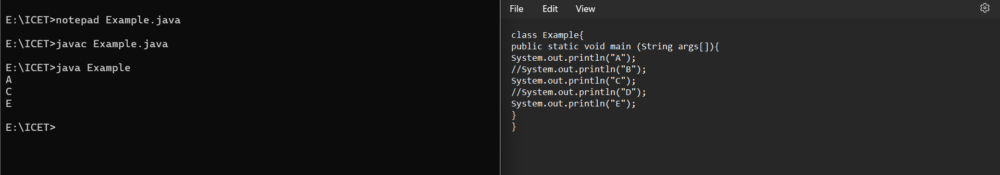

Q22.

class Example {

public static void main(String args[]){

System.out.println("A");

System.out.println("B");

/*System.out.println("C");

System.out.println("D");

System.out.println("E");*/

System.out.println("F");

}

}

//- Output

E:\ICET>java Example

A

B

F

E:\ICET>

Q23.

class Example {

public static void main(String args[]){

int x=100;

int y=200;

System.out.println(x);

System.out.println(y);

x=y;

System.out.println(x);

System.out.println(y);

}

}

//- Output

E:\ICET>java Example

100

200

200

200

E:\ICET>

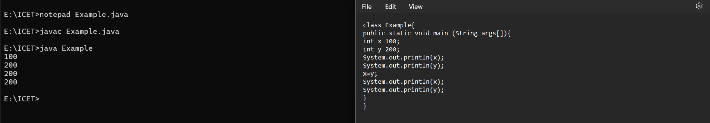

Q24.

class Example {

public static void main(String args[]){

System.out.println(true);

System.out.println("true");

}

}

//- Output

E:\ICET>java Example

true

true

Q25.

class Example {

public static void main(String args[]) {

System.out.println(Java);

System.out.println("Java");

}

}

//- Output

E:\ICET>javac Example.java

Example.java:3: error: cannot find symbol

System.out.println(Java);

^

symbol: variable Java

location: class Example

1 error

Q26.

class Example {

public static void main(String args[]){

System.out.println('A');

System.out.println("A");

System.out.println('2');

System.out.println("2");

System.out.println('JAVA');

System.out.println("JAVA");

}

}

//- Output

E:\ICET>javac Example.java

Example.java:7: error: unclosed character literal

System.out.println('JAVA');

^

Example.java:7: error: unclosed character literal

System.out.println('JAVA');

^

Example.java:7: error: not a statement

System.out.println('JAVA');

^

3 errors

Q27.

class Example {

public static void main(String args[]) {

System.out.println("Hellooooo\tJAVA");

System.out.println("Hellooooo\t\t\t\tJAVA");

}

}

//- Output

E:\ICET>java Example

Hellooooo JAVA

Hellooooo JAVA

Q28.

class Example {

public static void main(String args[]){

System.out.println("Hi\tJAVA");

System.out.println("Hello\tWorld");

}

}

//- Output

E:\ICET>java Example

Hi JAVA

Hello world

Q29.

class Example {

public static void main(String args[]){

System.out.println("AB\nCD");

System.out.println("");

System.out.println("EF\tGH\n\nIJ\tKL");

}

}

//- Output

E:\ICET>java Example

AB

CD

EF GH

IJ KL

Q30.

class Example {

public static void main(String args[]) {

System.out.println("time - "17:56:02");

}

}

//- Output

E:\ICET>javac Example.java

Example.java:3: error: ')' expected

System.out.println("time - "17:56:02");

^

Example.java:3: error: unclosed string literal

System.out.println("time - "17:56:02");

^

2 errors

Q31.

class Example {

public static void main(String args[]){

System.out.println("\'ICET\");

System.out.println("\"Institute of Computer Engineering Technology \"");

}

}

//- Output

E:\ICET>javac Example.java

Example.java:3: error: unclosed string literal

System.out.println("\'ICET\");

^

1 error

Q32.

class Example {

public static void main(String args[]){

System.out.println("First Line\nSecond Line");

System.out.println("A\tB\tC");

System.out.println("D\tE\tF");

}

}

//- Output

E:\ICET>java Example

First Line

Second Line

A B C

D E F

Q33.

class Example {

public static void main(String args[]){

System.out.println("AB\nCD");

System.out.println("AB\tCD");

System.out.println("AB\fCD");

System.out.println("AB\bCD");

System.out.println("AB\rCD");

System.out.println("AB\\CD");

}

}

//- Output

E:\ICET>java Example

AB

CD

AB CD

AB

CD

ACD

CD

AB\CD

Q34.

class Example {

public static void main(String args[]){

System.out.println(10+20);

System.out.println("10"+"20");

System.out.println("10"+20);

System.out.println(10+"20");

}

}

//- Output

E:\ICET>java Example

30

1020

1020

1020

Q35.

class Example {

public static void main(String args[]){

System.out.println(20230326);

System.out.println("2023-03-26");

}

}

//- Output

E:\ICET>java Example

20230326

2023-03-26

Q36.

class Example {

public static void main(String args[]){

int x,y,z;

x=10;

y=20;

z=x+y;

System.out.println(x+"+"+y+"="+z);

}

}

//- Output

E:\ICET>javac Example.java

E:\ICET>java Example

10+20=30

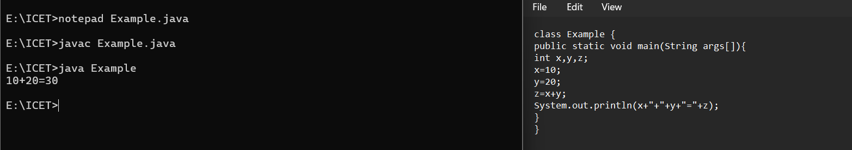

Q37.

**c**lass Example {

public static void main(String args[]){ int x=10,y=20;

System.out.println(x+y);

System.out.println(x+"y");

System.out.println("x"+"y");

System.out.println("x+y");

System.out.println("x"+y);

}

}

//- Output

E:\ICET>java Example

30

10y

xy

x+y

x20

Q38.

class Example {

public static void main(String args[]) {

System.out.println (10 + 20 + 30);

System.out.println ("10 + 20 +30");

System.out.println (10 + 20 + 30);

System.out.println("10+20"+30);

System.out.println("10"+"20"+"30");

System.out.println ("10"+ 20 + 30 );

System.out.println ( 10 + 20 +"30");

System.out.println(10+"20"+30);

}

}

//- Output

E:\ICET>java Example

60

10 + 20 +30

60

10+2030

102030

102030

3030

102030

Q39.

class Example {

public static void main(String args[]){

String sl="Hello";

System.out.println(s1);

System.out.println(sl.concat(" JAVA"));

}

}

//- Output

E:\ICET>javac Example.java

Example.java:4: error: cannot find symbol

System.out.println(s1);

^

symbol: variable s1

location: class Example

1 error

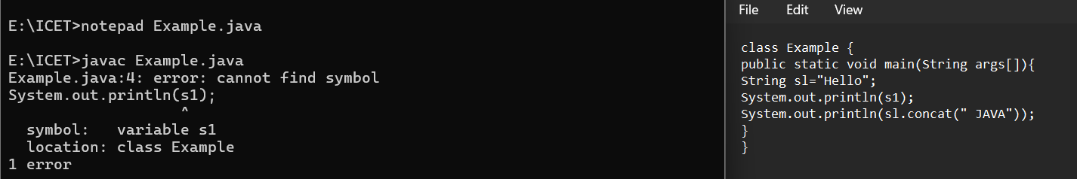

Q40.

class Example {

public static void main(String args[]){

int x, y, z;

x=10;

y=20;

z=x+y;

System.out.println(x+" + "+y+" = "+z); z=x-y;

System.out.println(x+" - "+y+" = "+z); z=x*y;

System.out.println(x+"*"+y+" = "+z);

}

}

//- Output

E:\ICET>java Example

10 + 20 = 30

10 - 20 = -10

10*20 = 200

Q41.

class Example{

public static void main(String args[]){

int x, y;

X=10;

Y=20;

System.out.println(x+”+”+y+”=”+(x+y));

System.out.println(x+”-”+y+”=”+(x-y));

System.out.println(x+”*”+y+”=”+(x*y));

}  
}

//- Output

E:\ICET>java Example

10+20=30

10-20=-10

10*20=200

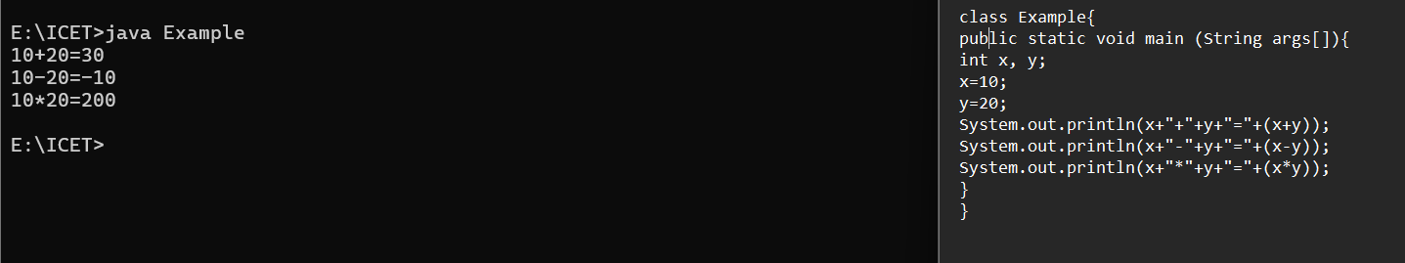

Q42.

class Example{

public static void main(String args[]){

int x, y;

X=100;

Y=200;

System.out.println(x);

System.out.println(y);

Y=x;

System.out.println(x);

System.out.println(y);

}  
}

//- Output

E:\ICET>java Example

100

200

100

100

Q43.

class Example{

public static void main(String args[]){

int num=103;

if(num>0){

System.out.println(num+”is positive number”);

} else if(num<0){

System.out.println(num+”is negative number”);

}else{

System.out.println(num+”is 0”);

}  
 }  
}

//- Output

E:\ICET>java Example

103id Positive number

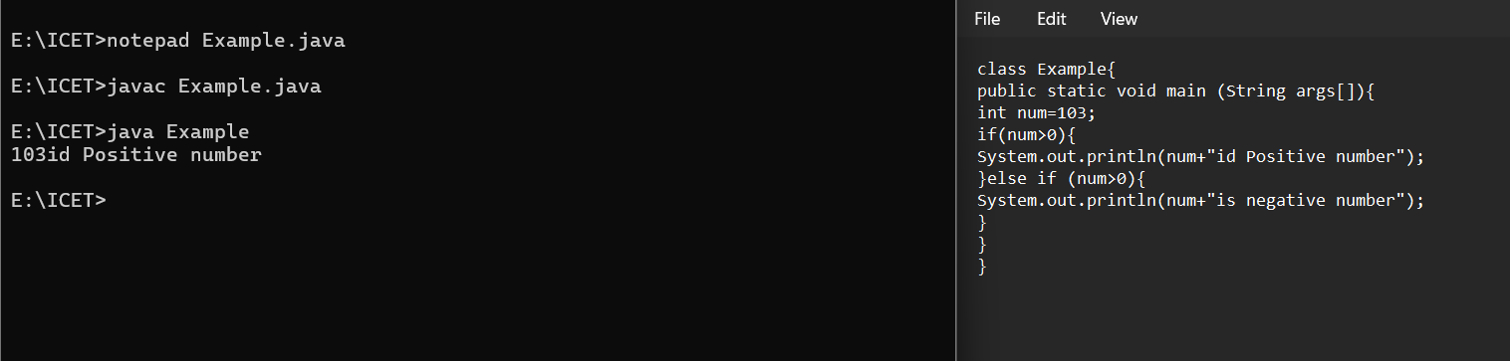

Q44.

import jva.util.*;

class Example{

public static void main(String args[]){

Scanner input = new Scanner(System.in);

System.out.println(“Input number-”);

int num=input.nextlnt();

if(num>0){

System.out.println(num+”is positive number”);

}else if(num<0){

System.out.println(num+”is negative number”);

}else{

System.out.println(num+”is 0”);

}  
 }  
}

//- Output

E:\ICET>java Example

Input number - 2

2 is positive number

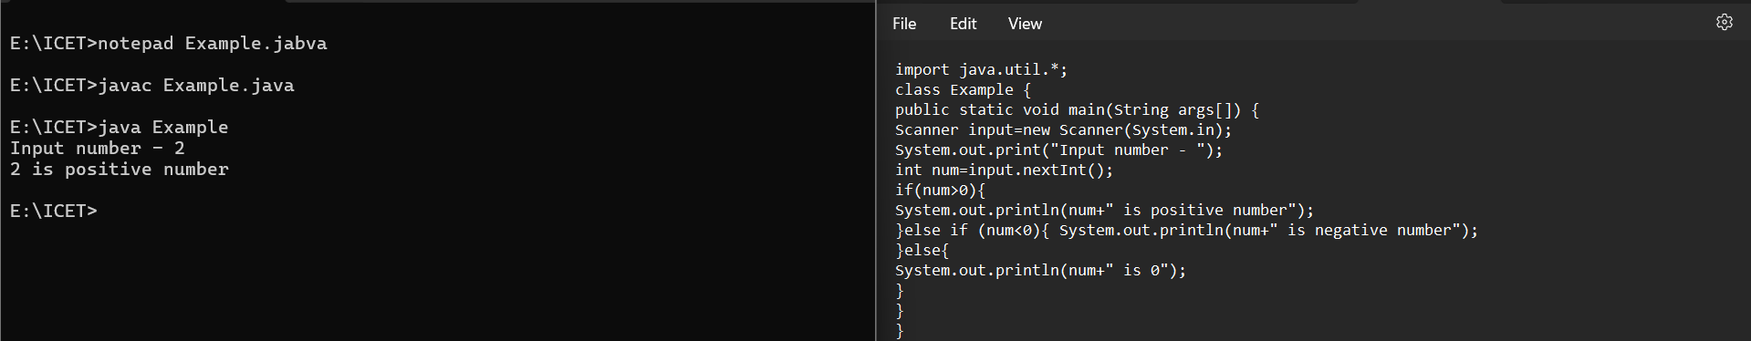

Q45.

import java.util.*;

class Example {

public static void main(String args[]) {

Scanner input=new Scanner(System.in); System.out.print("Enter your marks - ");

int mark=input.nextInt();

if(mark>=75){

System.out.println("your grade is A");

}else if (mark >=65){

System.out.println("your grade is B"); }else if(mark >=50) {

System.out.println("your grade is C");

}else{

System.out.println("your grade is F");

}

}

}

//- Output

E:\ICET>java Example

Enter your marks - 84

your grade is A

Q46.

import java.util.*;

class Example {

public static void main(String args[]) {

Scanner input=new Scanner(System.in);

System.out.print("Enter your age - ");

int age=input.nextInt();

if(age<18){

System.out.println("age is not valid to vote");

}else{

System.out.println("Welcome to vote");

}

}

}

//- Output

E:\ICET>java Example

Enter your age - 22

Welcome to vote

Q47.

class Example {

public static void main(String args[]) {

double x, y, z;

x=3;

y=4;

z=Math.sqrt(x*x + y*y);

System.out.println("Hypotenuse is" +z);

}

}

//- Output

E:\ICET>java Example

Hypotenuse is5.0

Q48.

import java.util.*;

class Example {

public static void main(String [] args) {

Scanner input=new Scanner(System.in);

System.out.print("Enter any number- ");

int num=input.nextInt();

int fact=1;

for(int i=1;i<num;i++){

fact=fact*i;

}

System.out.println("The factorial of" +num+"is"+fact);

}

}

//- Output

E:\ICET>java Example

Enter any number- 6

The factorial of6is120

Q49.

import java.util.*;

class Example {

public static void main(String [] args) {

Scanner input=new Scanner(System.in);

System.out.print("Enter your age - ");

int age=input.nextInt();

if(age < 18){

System.out.println("age is not valid to vote");

}else{

System.out.println("Welcome to vote");

}

}

}

//- Output

E:\ICET>java Example

Enter your age - 16

age is not valid to vote

Q50

public class Example{

public static void main(String args[]){

for (int i=5;i<6;i++){

int result = i! = 0 ? 100/I : 0;

if(i!=0){

System.out.println(“100/”+i+”is”+result);

}  
 }  
 }  
}

//- Output

E:\ICET>java Example

100/5is20

